

UNIT TITLE: ADVANCED WEB DESIGN AND DEVELOPMENT
STUDENT NAME: ROONEY S MUGACHA

ADMISSION NUMBER: BSCCS/2024/60056

COURSE: B.S.C COMPUTER SCIENCE
LECTURE: MR NYORO MICHAEL
SUBMISSION DATE: 6/5/2026

Table of Content
WEEK 1: LOCAL ENVIRONMENT SETUP 5
Figure 1. Apache and MySQL Running 5
Figure 2. Localhost Test Page 5
Fig 3: Hello World Test. 6
Fig 4: Database Connection Test. 6
WEEK 2: WIREFRAMES AND GUI DESIGN 7
Fig 1: Hand-drawn Wireframe. 7
Fig 2: Dashboard Layout Design. 8
Fig 3: Mobile View Mockup. 9
Fig 4: Color Theme and Navigation Structure. 10
FIG 5: GUI PROTOTYPE IN FIGMA. 11
WEEK 3 11
Fig 1: JavaScript Form Validation 11
Fig 2: Password Strength Checker 12
Fig 3: PHP Syntax Practice 13
Fig 4: Database Connection Script 13
Fig 5: Dynamic User Input Handling 14
WEEK 4 15
Fig1: Login form 15
Fig 2: JavaScript Form Validation 16
Fig 3: Folder structure 16
FIG 4: Database connection 17
Fig5 : GitHub weekly Update 17
WEEK 5 17
FIG1: USERS TABLE 17
FIG2:USER EMAIL AND DECRYPTED PASSWORD 18
FIG3: DISPLAY ALL USERS 18
FIG4: CREATION OF USER TABLE 18
FIG5: INSERTION IN TABLE 19
FIG 6: PRODUCT CRUD PAGE 19
FIG7: GITHUB WEEKLY UPDATE 19
WEEK 6 20
Fig 1: Handling Creation 20
Fig 2: Handling Update 20
FIG3: Handling Delete 21
WEEK 7 22

fig1:login verification ………………………………………………………………………………………………………….22
WEEK 8 23
FIG1: Responsive Web Design 23
FIG2: Media styling 24

WEEK 1: LOCAL ENVIRONMENT SETUP

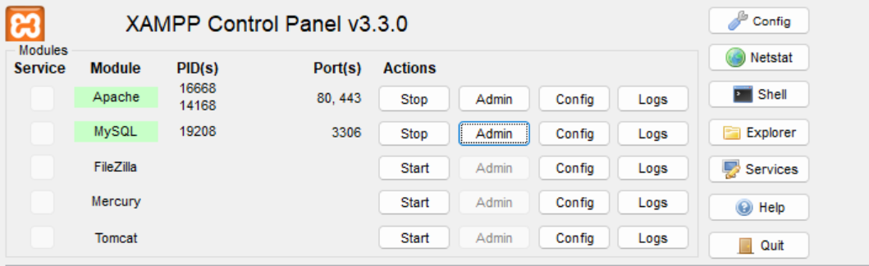

Figure 1. Apache and MySQL Running

This demonstrates a functional local development environment using the XAMPP control panel, confirming that both the Apache web server and MySQL database services are active and running.

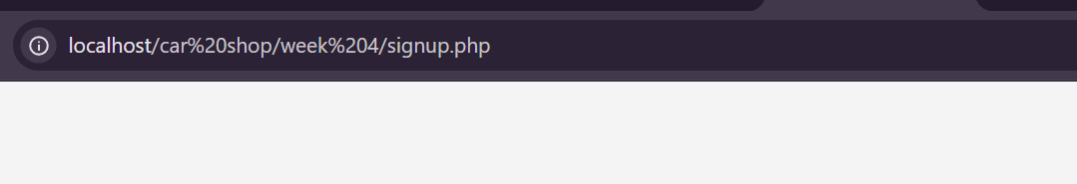

Figure 2. Localhost Test Page
This shows the successful resolution of the local loopback address in the browser, verifying that the local server is actively receiving and responding to HTTP requests.

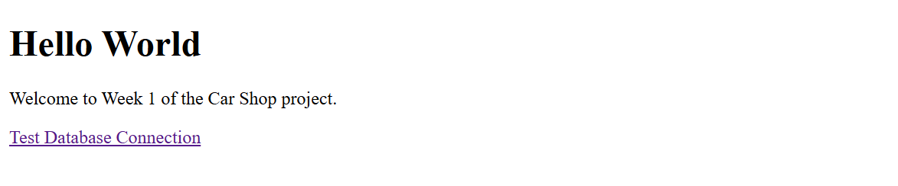

Fig 3: Hello World Test.
This screenshot demonstrates a basic script execution, verifying that the server's PHP engine is working correctly.



Fig 4: Database Connection Test.
This illustrates a successful backend handshake, proving that the PHP application can securely communicate with the local MySQL database instance.

WEEK 2: WIREFRAMES AND GUI DESIGN
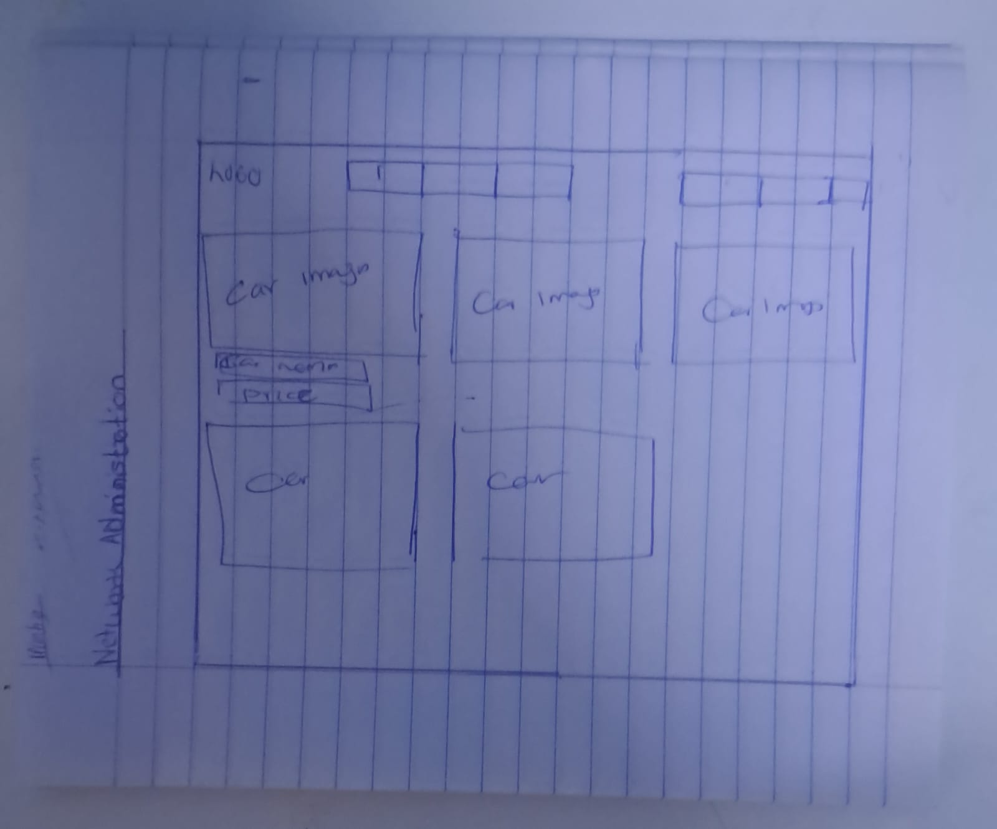

Fig 1: Hand-drawn Wireframe.

This image demonstrates the initial conceptual planning for the web application interface.

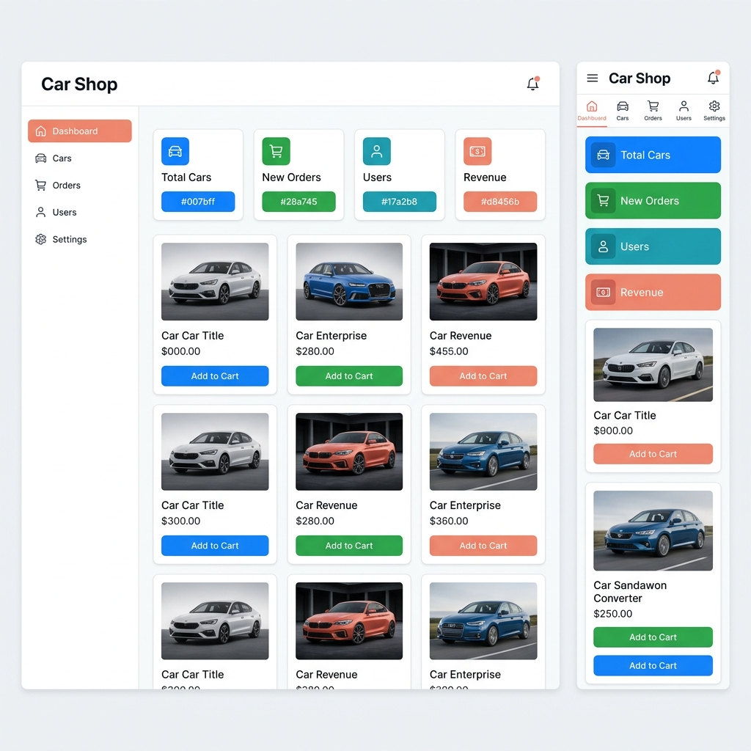

Fig 2: Dashboard Layout Design.

This screenshot shows the structured draft configuration of the user interface, mapping out where navigation controls and main content will be placed.


Fig 3: Mobile View Mockup.

This demonstrates the application's responsive design approach, showing how navigation menus (Buy a Car, Sell a Car, etc.) and image assets adapt to fit a mobile device screen.
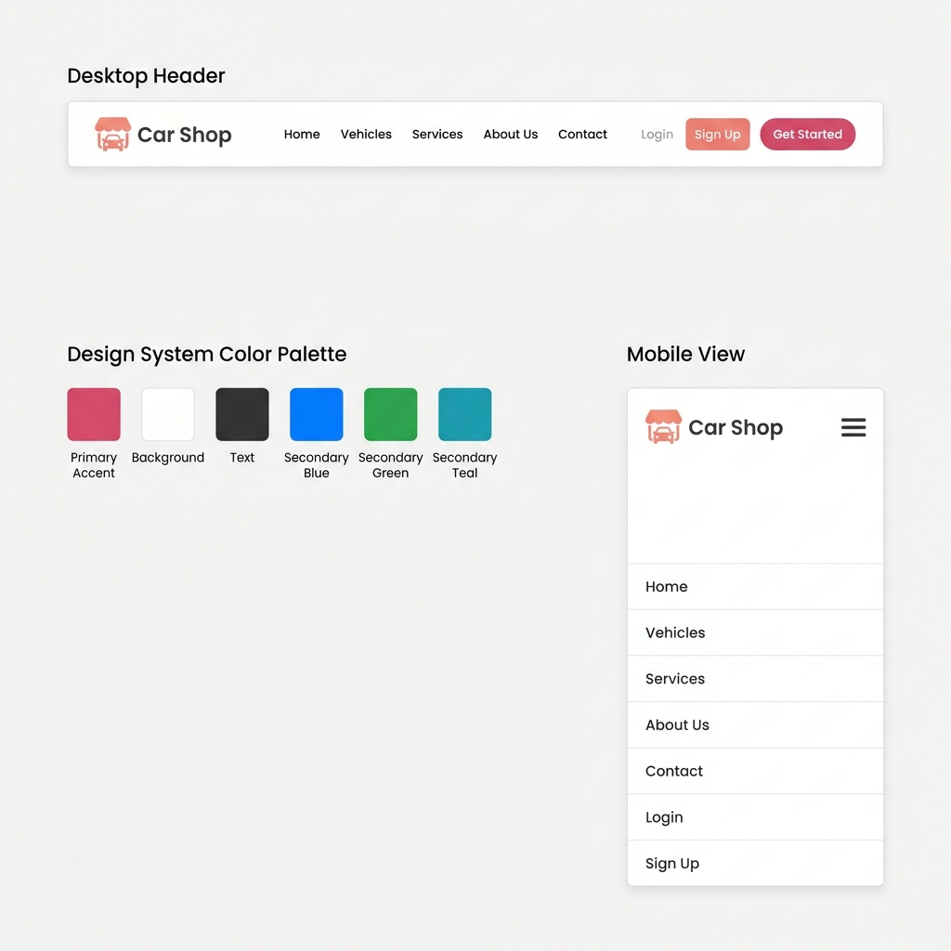

Fig 4: Color Theme and Navigation Structure.
This illustrates the established visual aesthetics, contrasting colors, and navigation flow designed to ensure a clean and consistent user experience



FIG 5: GUI PROTOTYPE IN FIGMA.

This demonstrates high prototypes of the final product, showing styled car listing cards (e.g., BMW X5, Mercedes-Benz) with prices and technical specifications.

WEEK 3

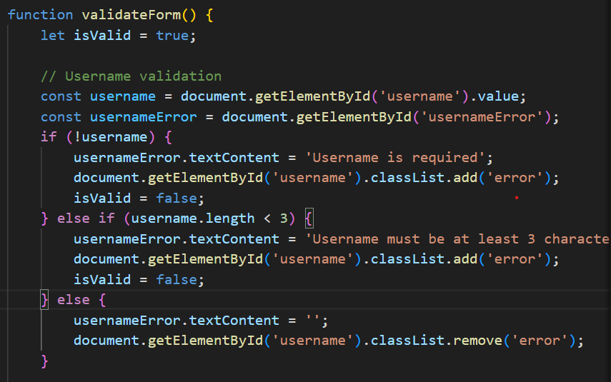

Fig 1: JavaScript Form Validation
This screenshot demonstrates client-side constraint logic, showing code that ensures a user cannot submit a form without a username or with a username shorter than 3 characters.
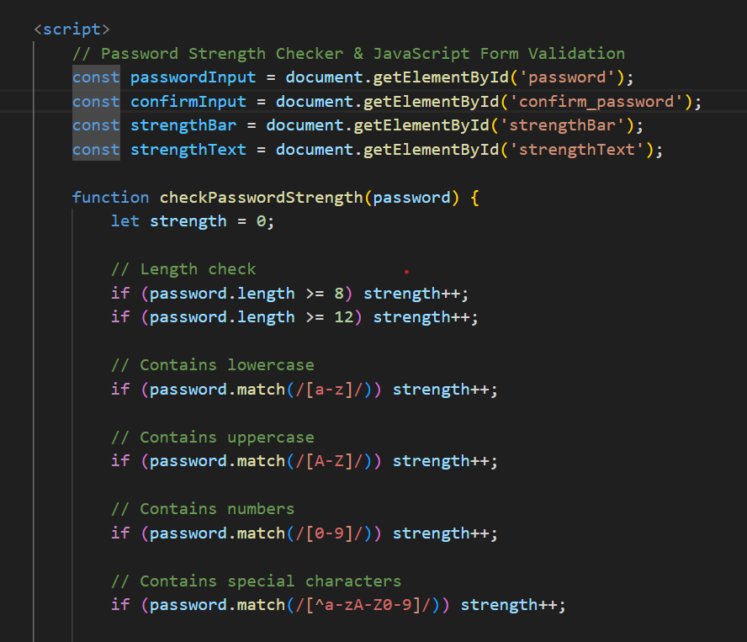

Fig 2: Password Strength Checker
function designed to evaluate a user's password entropy by checking for a combination of length, uppercase/lowercase letters, numbers, and special characters.

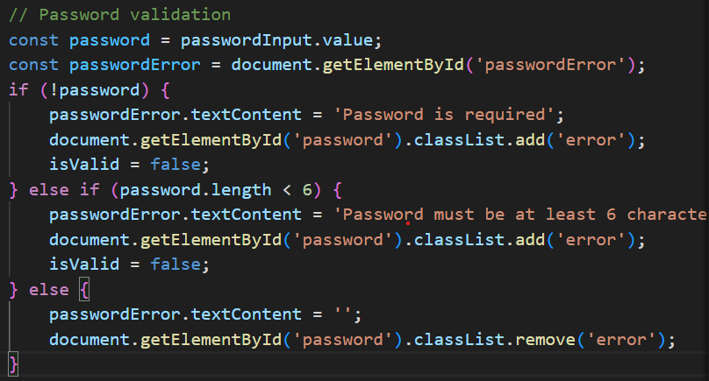

Fig 3: PHP Syntax Practice

This image demonstrates validation script logic capturing form state, handling dynamic error message displays, and toggling CSS error classes based on input validity.
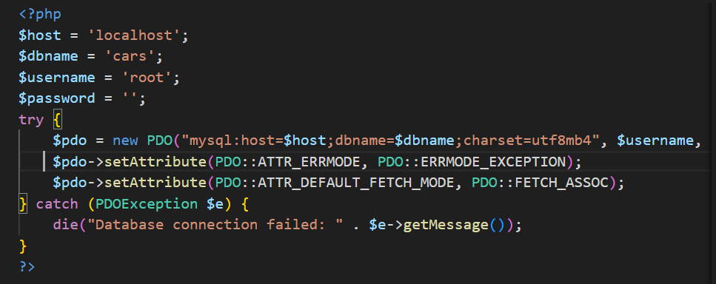

Fig 4: Database Connection Script

This shows a production-grade backend script configuring a secure PHP Data Object (PDO). It demonstrates best practices by utilizing a try-catch block to handle connection exceptions safely.
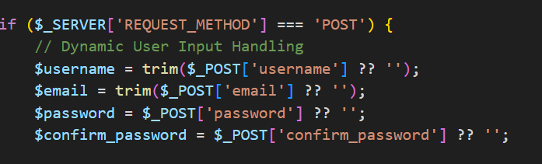

Fig 5: Dynamic User Input Handling

This demonstrates PHP server-side code capturing POST request parameters (username, email, password) and utilizing the trim() function to sanitize inputs by stripping unnecessary whitespace.

WEEK 4

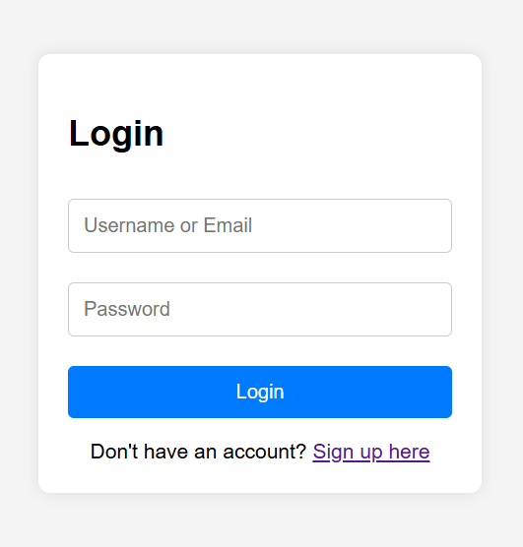

Fig1: Login form
This shows the user-facing graphical interface built for authentication, providing clean input fields for standard user identification.


Fig 2: JavaScript Form Validation
This demonstrates the integration of the previously built validation logic directly into the login/signup to catch user errors before reaching the server
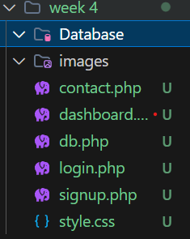

Fig 3: Folder structure
This image illustrates an organized and structured project directory, showcasing a clean separation of dedicated database/image folders

FIG 4: Database connection
This screenshot highlights the physical deployment structure inside the MySQL database, confirming the users table is active and ready to store information.

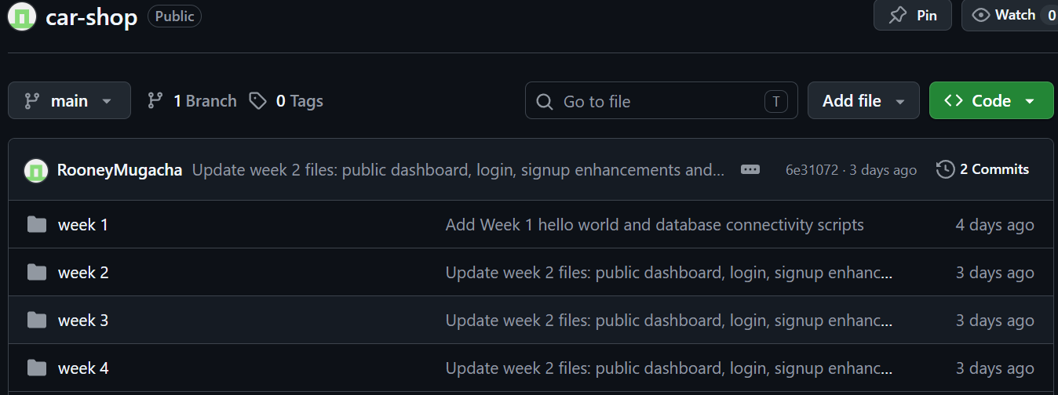

Fig5 : GitHub weekly Update
Showing an organized repository history with atomic commits that track the addition of features like the public dashboard and login enhancements.

WEEK 5

FIG1: USERS TABLE
The table meant to house user credentials

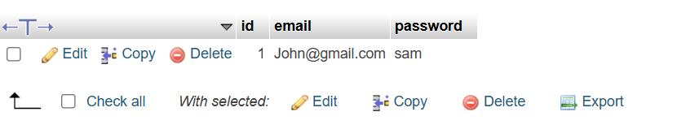

FIG2:USER EMAIL AND DECRYPTED PASSWORD
This demonstrates the successful manual insertion or verification of a database record within the users table, showing columns for id, email, and a plaintext password string for a registered user.
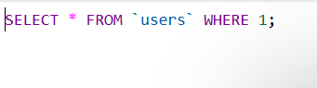

FIG3: DISPLAY ALL USERS

This highlights the execution and result of a SQL SELECT * FROM users; query, which retrieves and renders all active records currently stored within the authentication table.

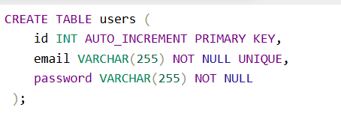

FIG4: CREATION OF USER TABLE
This shows the SQL Data Definition Language (DDL) script used to programmatically build the database structure. It establishes an auto-incrementing primary key (id) and ensures data integrity by enforcing a NOT NULL UNIQUE constraint on the email field.

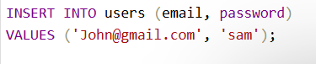

FIG5: INSERTION IN TABLE
This illustrates a Data Manipulation Language (DML) SQL statement (INSERT INTO) or its equivalent backend routine executing a command to inject new administrative or user credentials into the database.

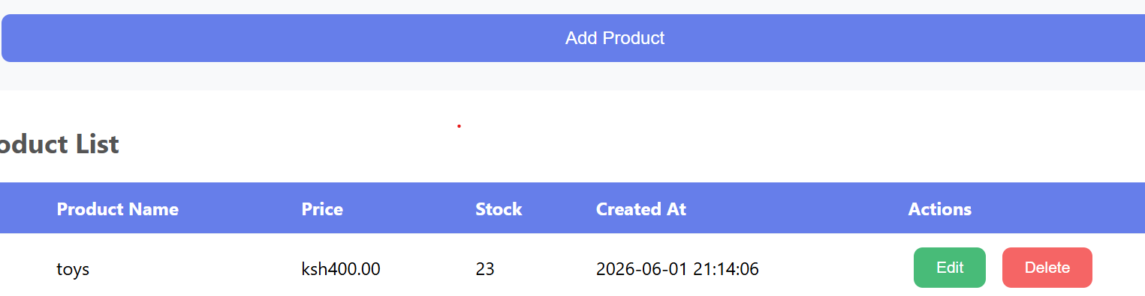

FIG 6: PRODUCT CRUD PAGE
This demonstrates a functional user interface for handling inventory, featuring a "Product List" data table with actions to Create, Read, Update, and Delete (CRUD) entries like item name, price, and stock levels.
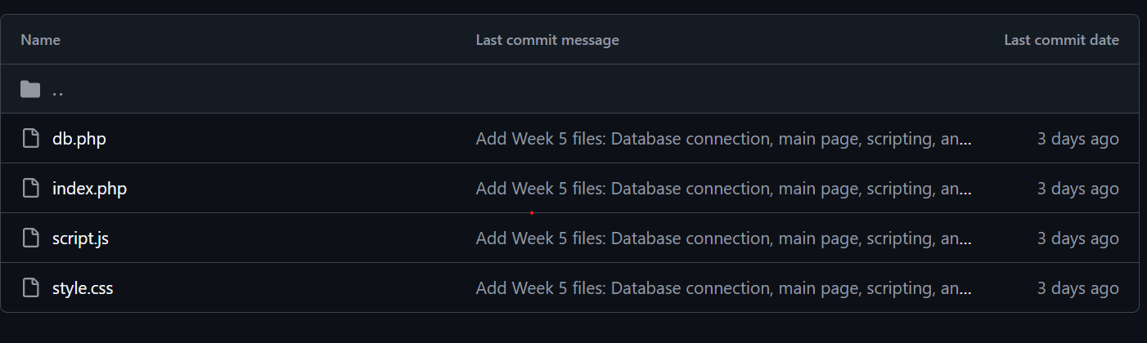

FIG7: GITHUB WEEKLY UPDATE
This captures the version control history on GitHub for Week 5, showing a clean, modular repository file structure (db.php, index.php, script.js) alongside commit messages detailing backend and frontend scripting updates.
GitHub repo: https://github.com/RooneyMugacha/car-shop

WEEK 6

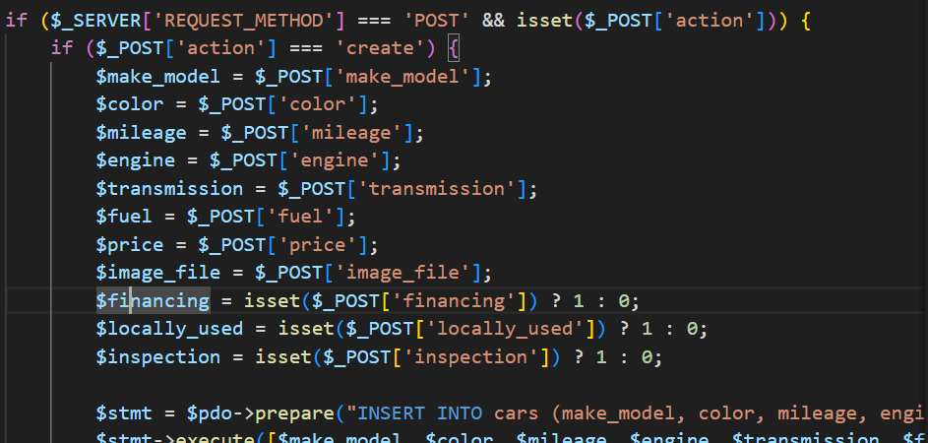

Fig 1: Handling Creation
This figure demonstrates the process of inputting data

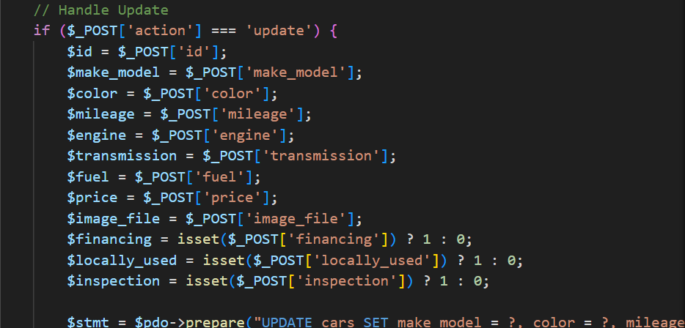

Fig 2: Handling Update
After the user modifies the data and submits the form, the system identifies the specific record (usually via a unique ID) and overwrites the old information with the new data in the database.
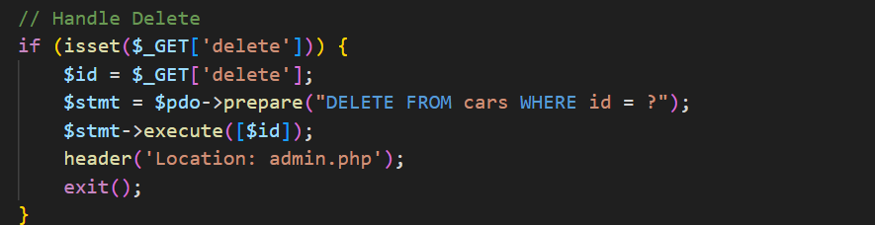

FIG3: Handling Delete
This process involves the removal of a specific database entry.

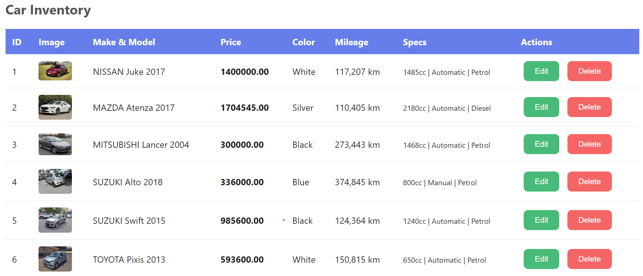
FIG4: CRUD PAGE
It is the main page where users can view all the data that exists in the system. This page typically serves as the central hub that links all the other functions together.

WEEK 7

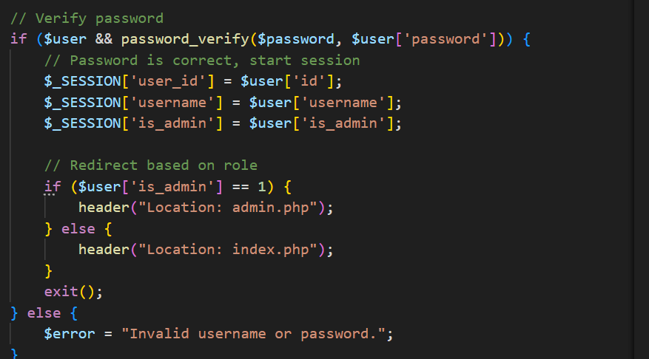

FIG1: LOGIN VERIFICATION
This figure demonstrates the authentication process. "Login Verification" is the mechanism that checks a user's credentials against the stored data in the database.

WEEK 8

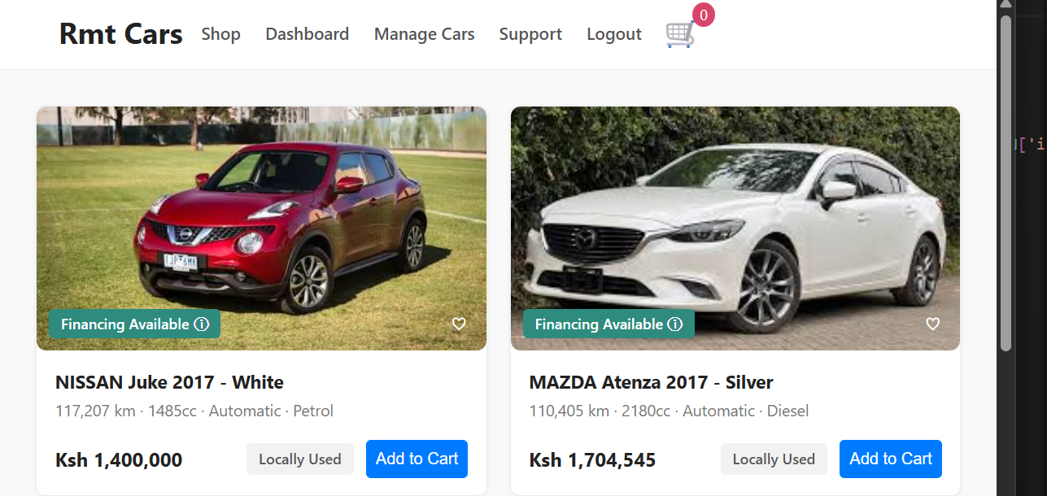

FIG1: Responsive Web Design
Responsive Web Design ensures that a website looks good and functions properly on all devices desktops, tablets, and phones. This is achieved using CSS techniques like Flexbox, Grid, and Media Queries.

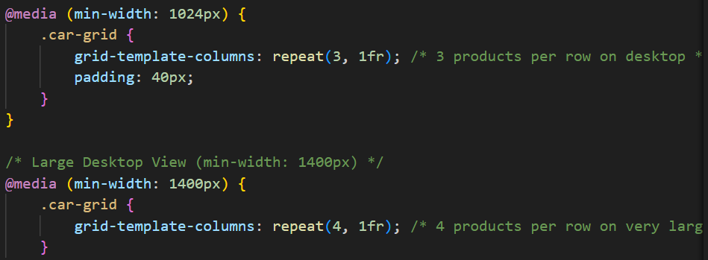

FIG2: Media styling
Media styling refers to the CSS rules that control how non-textual content is displayed. This involves making images responsive e.g., max-width: 100% to prevent them from overflowing their containers), adding borders, shadows, or hover effects

